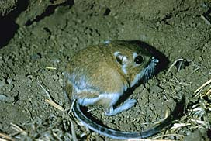
Kangaroo Rat
Kangaroo Rats are often the prey of other animals
(this means that other animals like to eat kangaroo rats!).
They survive by being able to jump great distances.
They can jump up to 15 feet in a single bound!
How far can you jump?
Jump beside the red rope.
The distance between each tape marking is one foot.
Record how far you jumped on your Animal Olympics Scorecard.

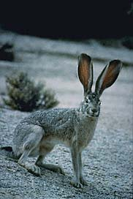
Jackrabbit
Fast predators, like coyotes, often chase the jackrabbit.
To escape, they can hop up to 59 feet per second
(or 590 feet in 10 seconds, or more than two-thirds of a mile in 1 minute!).
How far can you hop in 10 seconds?
Have a friend use a timer provided.
When they say “go” hop beside the red rope.
The distance between each tape marking is one foot.
Record how far you hopped on your Animal Olympics Scorecard.

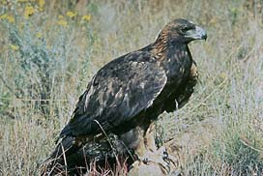
Eagle
Eagles have a wingspan of over 7 feet long.
Those huge wings allow eagles to soar high in the air and cool off.
Measure your wingspan.
Spread your arms as wide as you can.
Use the tape measure provided to record from the fingertips of one hand, across your chest, to your opposite hand for your wingspan.
Record your wingspan on your Animal Olympics Scorecard.

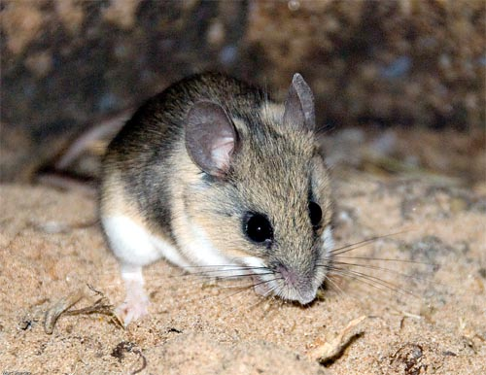

Deer Mouse
Some animals can get their water needs met by what they eat.
Deer mice get their water by eating seeds.
Deer mice can fit over 900 seeds in their cheek at one time!
How many seeds can you put in a cup in one minute?
Have a friend use a timer provided.
When they say “go” place one seed at a time in a cup.
After one minute count how many seeds you placed in the cup.
Record your answer on your Animal Olympic Scorecard.

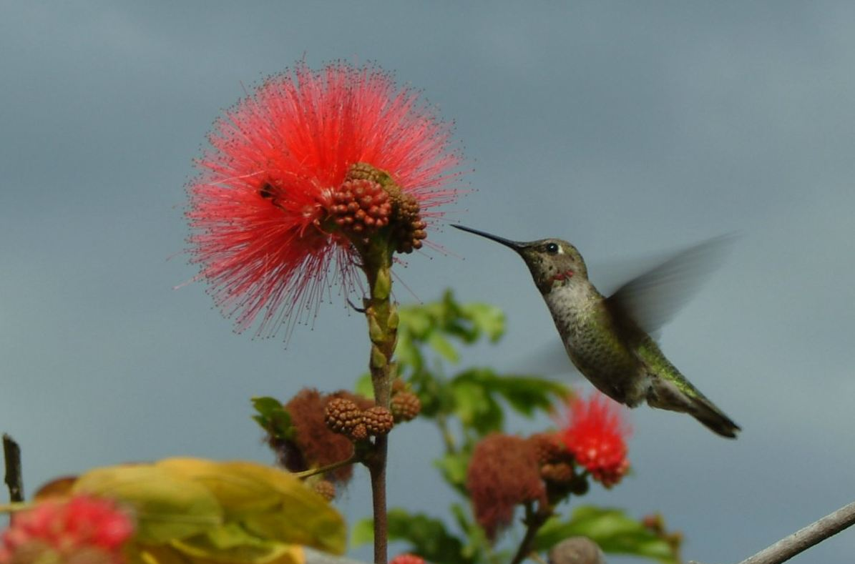
Hummingbird
Hummingbirds can hover, and even fly backwards!
They can do this because they can flap their wings
up to 79 times in a single second!
(That is 790 times in 10 seconds, or 4740 times in one minute!)
How many times can you flap your arms in 10 seconds?
Have a friend use a timer provided.
When they say “go” flap your arms up and down for 10 seconds.
Record your answer on your Animal Olympic Scorecard.

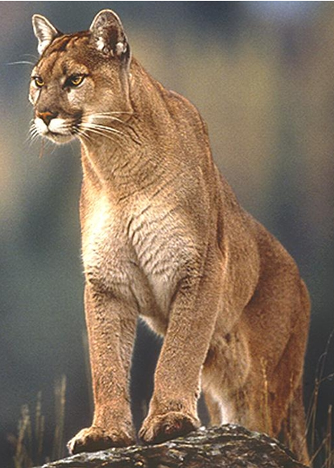
Mountain Lion
Mountain lions have very strong legs.
To move quickly through the rough land, they have the ability to
jump 20 feet straight up in the air!
This is like jumping to the top of a 2-story building from a standstill!
How high can you jump- from a standstill?
Jump straight up beside the measuring stick.
Have a friend watch to see how far your feet get off the ground.
Record how far you jumped on your Animal Olympics Scorecard.

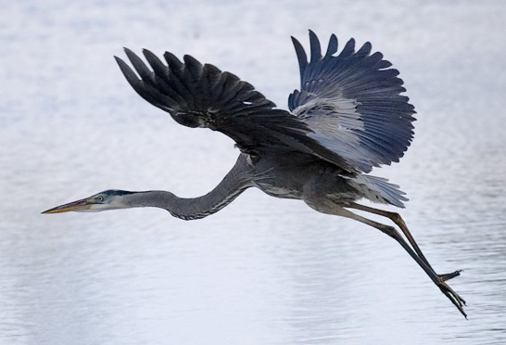
Great Blue Heron
Great Blue Herons can stand on one leg,
with their eyes closed, for over an hour.
They do this so that fish will swim close to them, and the
heron will be able to quickly snatch one for dinner.
How long can you stand on one leg, with your eyes closed?
Have a friend use a timer provided.
When they say “go” close your eyes and stand still on one leg.
Stop the timer when you either put your foot down or open your eyes.
Record how long you stood on your Animal Olympic Scorecard.

FOR EDUCATORS ONLY!!!!!

MATERIALS LIST FOR ANIMAL OLYMPICS

Station One:
Outside in the grassy area
Kangaroo Rat sign
Jackrabbit sign
red rope with masking
tape markings
timer
pens or pencils

Station Two:
Inside on round tadpole table
(Relocate tadpoles for the day)
Eagle sign
measuring tape
pens or pencils

Station Three:
Science Table in Yellow Tent
Deer Mouse sign
Dixie cups
timer
dried beans
pens or pencils

Station Four:
Inside on round table by the
ant hill
Hummingbird Sign
Heron sign
timer
pens or pencils

Station Five:
Outside the door of Yellow
Tent on a round table
Mountain lion sign
Measuring stick
pens or pencils

For everything YOU NEED:
7 animal signs
5 Animal Olympic Station signs
1 red rope with masking tape
markings
3 or more timers
5 or more pens or pencils
1 measuring stick
1 measuring tape
Dixie cups
dried beans

