American Bullfrog
Lithobates catesbeianus
Found in all of Maryland.
American Bullfrogs are prey for other animals.
They survive by being able to jump great distances.
They can leap over 7 feet in a single bound!
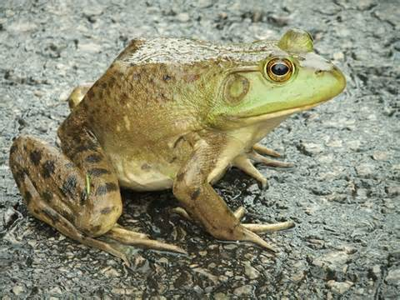

How far can you jump?
Standing at one end of the rope, jump once as far as you can.
The distance between each tape marking is one foot.
Record how far you jumped on your Animal Olympics scorecard.

American Bullfrog materials:
- 7 foot rope
- clipboard with wet erase marker attached
- instruction sheet

Eastern Cottontail
Sylvilagus floridanus
Found in all of Maryland.
Fast predators, like coyotes, often chase Eastern Cottontails.
To escape they can hop up to 26 feet per second.
That’s 130 feet in 5 seconds!
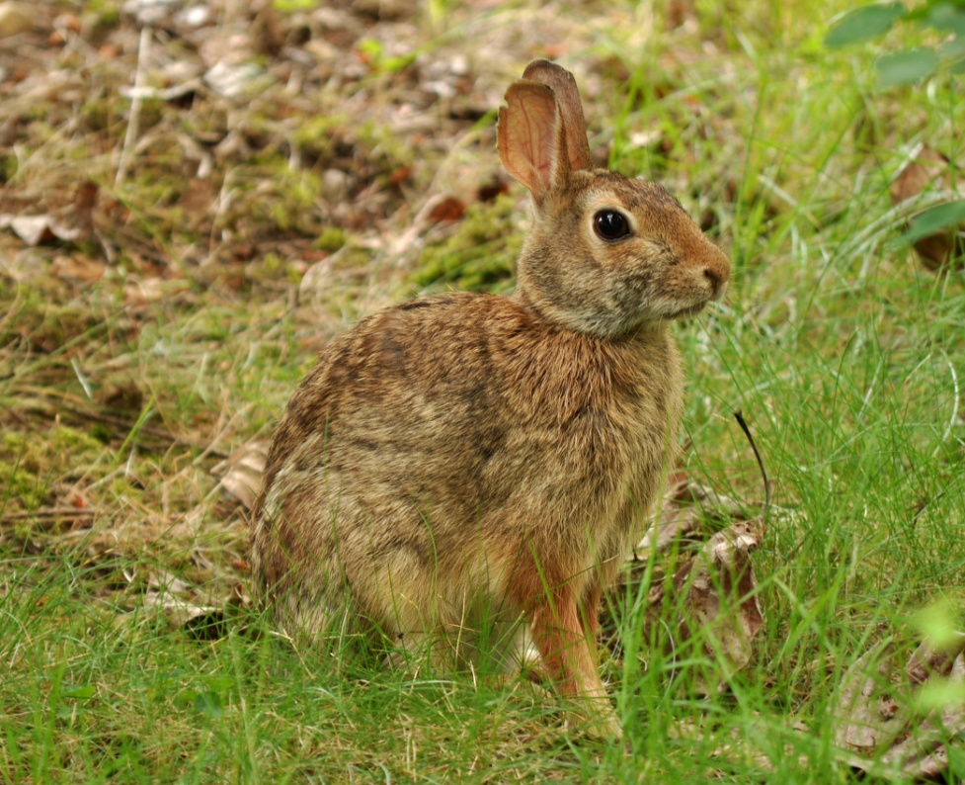

How far can you hop in 5 seconds?
Have a friend use the timer provided.
When they say “go” hop beside the rope until they say “stop”.
The distance between each tape marking is one foot.
Record how far you hopped on your Animal Olympics scorecard.

Eastern Cottontail materials:
- outdoor tape measure
- timer
- clipboard with wet erase marker attached
- instruction sheet

Bald Eagle
Haliaeetus leucocephalus
Found in Eastern Maryland.
Bald Eagles have a wingspan 7 feet wide.
Their huge wings help them to soar high in the air.
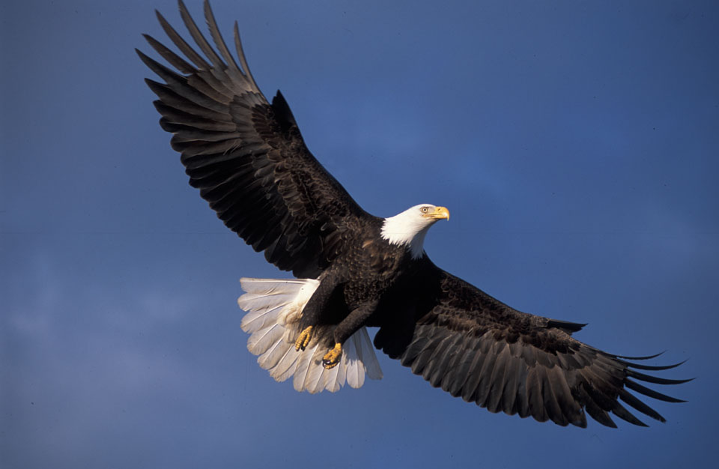

Measure your “wingspan.”
Spread your arms as wide as you can.
Have a friend use a tape measure from the fingertips of one hand, across your back, to the fingertips on the opposite hand.
Record your “wingspan” on your Animal Olympics scorecard.

Bald Eagle materials:
- tape measure
- clipboard with wet erase marker attached
- instruction sheet

Deer Mouse
Peromyscus maniculatus
Found in Western Maryland.
Some animals get their water needs met by what they eat.
Deer Mice get their water by eating seeds.
They can fit over 900 seeds in their cheek at one time!
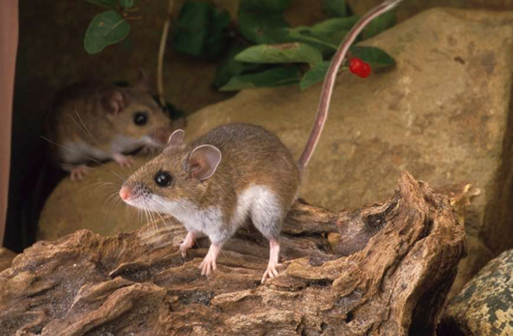

How many seeds can you put in a cup in 1 minute?
Have a friend use the timer provided.
When they say “go” place one seed at a time in the cup until they say “stop”.
Count how many seeds you placed in the cup.
Record how many seeds you placed in the cup on your Animal Olympics scorecard.

Deer Mouse materials:
- timer
- plastic cup
- bag of beans
- clipboard with wet erase marker attached
- instruction sheet

Mountain Lion
Felis concolor
Regionally extinct in Maryland but was native.
Mountain Lions have very strong legs.
To move quickly over rough terrain they have the ability to jump 20 feet straight up in the air.
That is like jumping to the top of a two story building!
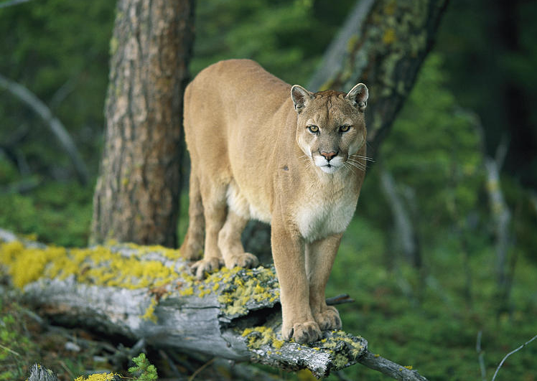

How high can you jump?
Jump straight up beside a measuring stick.
Have a friend watch to see how far your feet get off the ground.
Record how high you jumped on your Animal Olympics scorecard.

Mountain Lion materials:
- yard stick
- clipboard with wet erase marker attached
- instruction sheet

Great Blue Heron
Ardea herodius
Found in all of Maryland.
Great Blue Herons can stand on one leg with their eyes closed for over an hour.
They do this so fish will swim close to them, and the heron will be able to quickly snatch one for dinner.
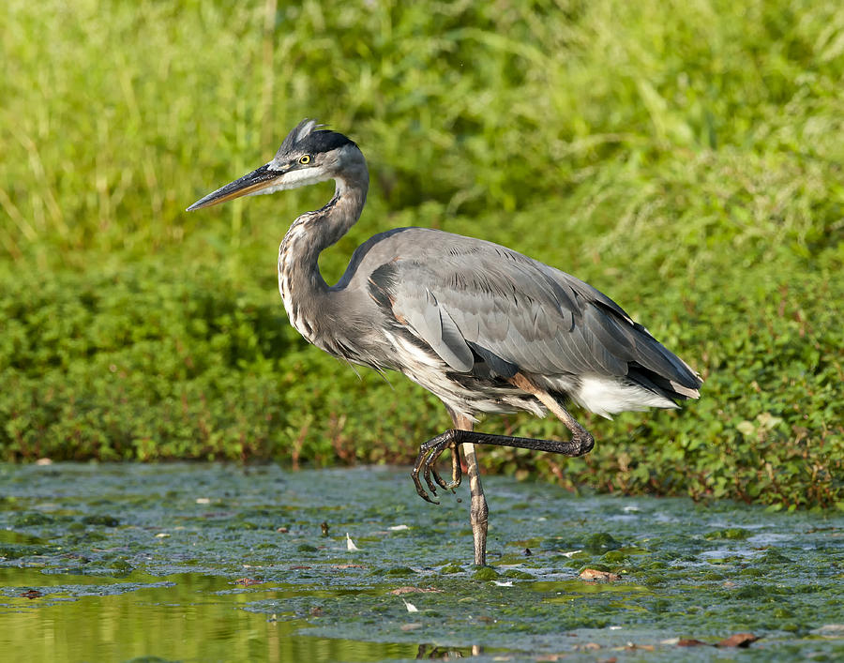

How long can you stand on one leg with your eyes closed?
Have a friend use the timer provided.
When they say “go” stand on one leg and close your eyes.
Your friend will stop the timer when you either put your foot down or you open your eyes.
Record how long you stood on your Animal Olympics scorecard.

Great Blue Heron materials:
- timer
- clipboard with wet erase marker attached
- instruction sheet

Ruby-Throated Hummingbird
Archilochus colubris
Found in all of Maryland.
Hummingbirds are able to hover in one place.
They can do this because they can flap their wings up to 79 times in a single second.
That’s 790 times in 10 seconds!
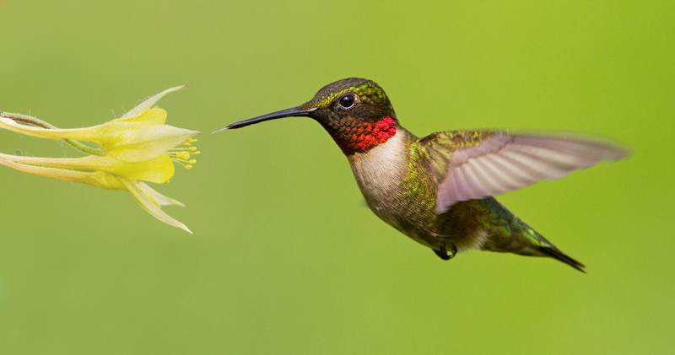

How many times can you flap your arms in 10 seconds?
Have a friend use the timer provided.
When they say “go” flap your arms all the way up and all the way down until they say “stop”.
Record your answer on your Animal Olympics scorecard.

Hummingbird materials:
- timer
- clipboard with wet erase marker attached
- instruction sheet

Animal Olympics Inventory
- clipboards with wet erase marker attached (7)
- instruction sheets (7)
- outdoor tape measure
- 7 foot rope
- timers (4)
- tape measure
- plastic cup
- bag of beans
- yard stick
Instructions
- Set out materials at each of the seven stations. Material lists for each station is located on the back of the instruction sheets.
- Talk to the kids about the Olympics, how human athletes show off their athletic skills. Explain that animals in Maryland also have athletic skills. We want to see how they compare to the animals.
- Ask the kids to find a partner. Assign each group a station to start. When they finish their station they should move to different station. Remind them to complete all seven stations (it is not necessary they do them in order).

