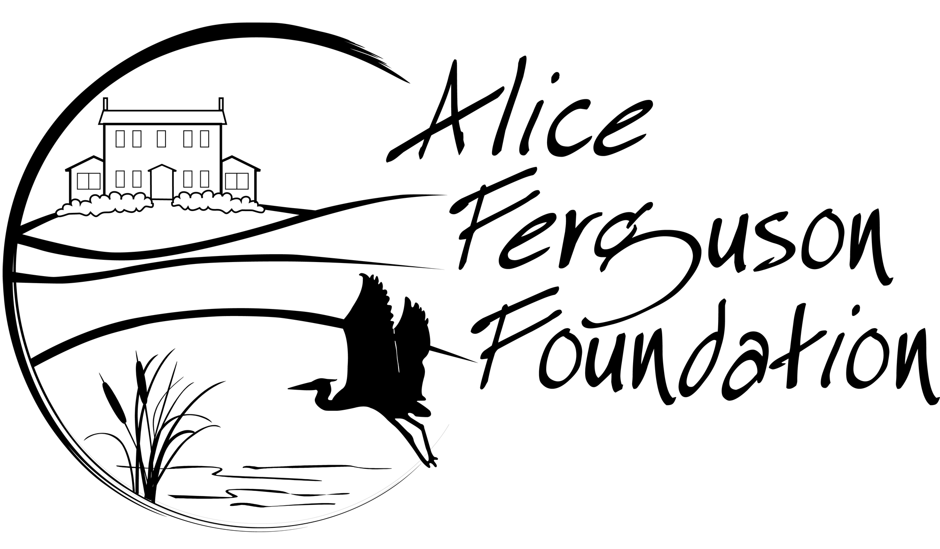
Make-a-Macro
Discussion Questions
Your assignment is to create an original, fictitious macroinvertebrate that has all of the body parts on the cards you randomly selected. You will need to select parts to complete your macroinvertebrate and then answer the questions below.
1. What name did you choose for your macroinvertebrate and why?

2. Where does the macroinvertebrate live and what adaptations help it survive in its environment?

3. What is an adaptation that helps it hunt or find food?

4. What is an adaptation that helps it defend itself?

5. Does it have behavioral adaptations?

